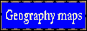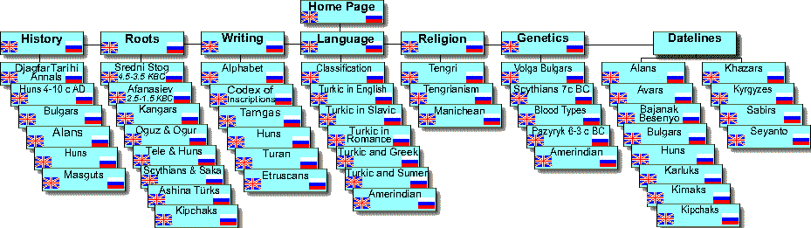
Latest Additions  Hamidullin S. Bashkort Huns and Bashkort Kangars  Sevortyan E. Listing of Türkic Languages  Doerfer G. Language of Huns  Mordtmann A. D. Behistun Elamite Inscription  Hinz W. Elamite Dictionary  Vaissiere E. Eastern Huns synopsis  Vaissiere E. Eastern Huns name  Added Terentiev V. Türkic in Europe  Added Rojansky I. Scythian Y-DNA R1a-Z2125  Added Shevchenko M. Eurasian Huns Maps  Added Golden P. Hunnic Language  Added Anokhin V.Scythian Atail's Coin  Added Kamoliddin Sh. Turkic Agriculture  Added Hasanov Z. Issyk Inscription  Added Allili E.Turkic Akkadian  Added Hamori F. Multilanguage Swadesh  Added Scherbak A. Animal Names  Added Kisamov N. TarimGuties  Added Kamoliddin Sh. Samanids  Added Marcantonio A. Hoax of IE family  Added Balkan K. Gutian Language  Added Kim H.J. Huns and Europe  Added Kisamov N. Hunnic Oracle  Added Clauson G. Turkic Etym. Dictionary  Added Celtic Archeology  Added Klyosov A. Kurgan Theory  Added Kisamov N. Turkic substrate in English  Added Chernykh E. Steppe Metallurgy  Added Dremin G. Abaev's Scythian Hoax  Added Klyosov A. R1b DNA History  Added Kisamov N. Scytho-Iranian Theory  Added Chikisheva T. Anthr. S.-W. Siberians  Added Veles Book | Previous Additions  Karatay O. Origins of Croation Nation  Tekin T. Hunnic Phrase  Dremin G. Scythian Lexicon  Hamori F. Issyk Inscription  Karatay O. Eastern Sources on Croats  Golden P. Khazar Conversion  Hosszu G. Rovash Runic Script  Curta F Making of the Slavs  Ivik, Kluchnikov Khazars  Younger EDDA  De Administrando Imperia  Mukhamadiev A Imenkov ingots  Sevortyan E. Turkic Etymological Dictionary  OT Dictionary Affixes  Swadesh for Ossetian  Bela G. Dravidian Dictionary  Kisamov N. Kayi & Gelons  Tolstov S. Ancient Horezm  Krantz G. Geogr. Devel. Of Eur. Languages  Klyosov A. Autochthonous Altai DNA  Rtveladze E. Ancient Coins of Middle Asia  Drozdov Turkic Europeans  L.Gmyrya Caspian Huns  Runciman S Bulgar Empire  W.B. Henning Guties  Adji M. In Hindustan  Faux D. Kurgan Culture in Scandinavia  Gimbutas M. Kurgan Europe  Adji M. Tengriism and Arianism  Mukhamadiev A. New Look at Huns  Mukhamadiev A Khazar Coins  Winters C. Tocharian is Indian | Older Additions  Turkic Genetic Graphs  Djagfar Tarihi PDF  Western Huns Khans  Anatolian Tribes  Olhovsky V. Tamga  V.S.Taskin Hun Language  Aliev K.Bulgar Khan Nominalia  Yablonsky Sarmat Paleoanthropology  Frye R. Central Asian Linguistics  Shuke G. Türkic substrate of Slavic and Baltic  K.Csornai Huns in Chinese names  A.A.Klyosov Türkic DNA genealogy  Gumbatov G.Pazyryk red dye  Mokhammedyar Kazan Tarihi  K.Laipanov, I.Miziev Türkic people Origin  Dybo A. Pra-Altaian World  Dybo A. Linguiv. contacts of Early Turks  Kurbanov A. Hephthalites  V.S.Taskin Huns Issue 1 1968  Kudaev M. Zelenchuk inscription  V.S.Taskin Jie Huns Issue 2 1990  L.T. Yablonsky Ancient Chorasmia  N.Bichurin Hunnu  L.Potapov Origin of Altaians  E.N.Shipova 2000 Turkisms in Russian  C.C.Lamberg-Karlovsky Bronze Age Indo-Iranians  I.Taylor The Alphabet  A.Toth Agglutinative languages  Yu. A. Zuev Early Türks  Starostin S. Etymology Of Altaic  Toth A. Turkic-Hungarian  Moravcsik Gy. Turkic Christianity  Swadesh for Urdu | This page last updated  18 Nov 2012  Online since 1-22-02  all rights reserved  Altaic Historiography  Dybo A. Pra-Altaian World  Guties Synopsis  Stearns P.N. Zhou Synopsis  Sarmat Synopsis  Ishjamts N. Hunnic synopsis  Vaissiere E. Eastern Huns synopsis  Eastern Hun Anabasis  Debevoise N. Parthia  Wikipedia Uysyn  Bariev R. Bulgarian Synopsis  Burgund Synopsis  Khazar Synopsis  Kipchak Khanate Synopsis  Kumyk Dateline  Hungarian dateline  Burgund Dateline | Contents can also be found  at a number of Mirror Sites

