Home  Back  In Russian  Contents Huns  Contents Bulgars | Sources  Roots  Writing  Language  Religion | Genetics  Geography  Archeology  Coins  Wikipedia | Z.Miftakhov On Sabirs  Kamoliddin Toponymy | Besenyos, Ogur and Oguz  Kurgan Culture  Andronov Culture  Afanasiev Culture  Karasuk Culture  Russian Version needs a translation | Alan Dateline  Avar Dateline  Besenyo Dateline  Bulgar Dateline  Huns Dateline  Karluk Dateline | Kimak Dateline  Kipchak Dateline  Khazar Dateline  Kyrgyz Dateline  Sabir Dateline  Seyanto Dateline

SABIRS
Sabirs, Sabaroi, Sabiri, Savari, Sabans, Sibirs, Suvars, Zubur, Subartuans, Chuvash
Aksuvars, Aksungurs, Severyans, Sevruks (Siberian Tatar folklore) and other variations
The self-designation of the Georgian ethnic group Svan (Svanetia) is Shüanär, which is consistent with assertion that Svans are descendents of Türkic Suvars-Subars-Sabirs, and their history belongs both to the Georgian history and Suvar history. See L.Gmyrya Caspian Hun Country
Archeological Culture
Romen (Роменская) http://ru.wikipedia.org/wiki/Роменско-борщевская_культура
a little nugget at www.hostkingdom.net/siberia.html
SABIR A Hunnic tribe that briefly established a powerful state north of the Caucasus. They were attested in Mesopotamia ca 2000 BC. and again in 900 BC. They may have been attested to as early as 124 BCE, in which case they are ultimately Sarmatian or Scythian in origin. They were allied with Sassanid Persia until c.550, when they were enticed to join a Byzantine-led coalition.
To the Huns.395-460 CE
Independent Khanate 460-560
Belek...early 500's-520's
Bogarik (fem.)...520's-550's
To the Avars...560-600
To the Gok Turks...600-630
Possibly one of the component peoples of the Khazar Kaganate

Subar/Sabir/Suvar/Chuvash Anabasis
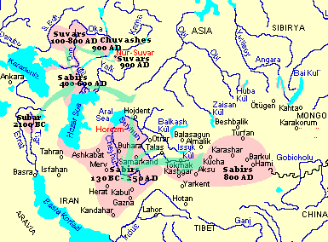
Political map of Eastern Europe ca 800 AD
showing Suvar domain within Khazar Kaganate
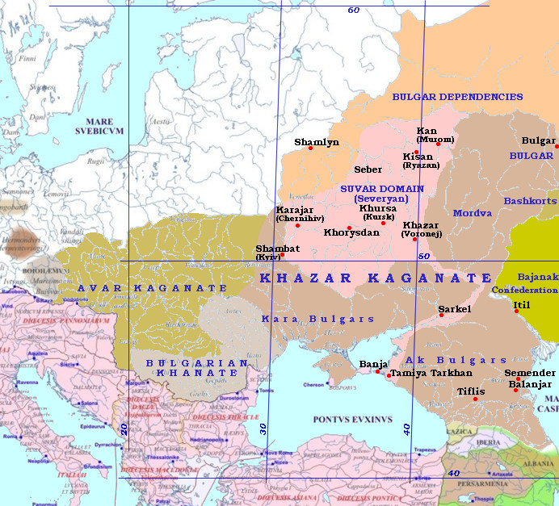

DATELINE
Time | Events
2,500 BC | In the historical period, Sabirs had inglorious beginning. In earliest Mesopotamia, the word “Subarian“ became a synonym for slave. Apparently, Sabirs were kyshtyms of the Sumerian Kangars | 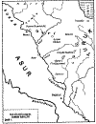
750 BC | Hesiod, 7th Century BC, writes: Inventors of bronze working were Scythians. The early Mesopotamian name for metal is Zubur, indicating that northern Mesopotamian Subartuans or a people of that region were indeed inventors of process. | 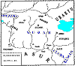
124 BC | Sabir (Sabaroi) are allied with Asi (Ases, Yazig, or Asiani), and Tochars, break into Sogdiana and Bactria. In next five years two Parthian emperors loose their lives in wars. Later Sakauraka (Türkic ‘Saka-farmers’) tribe is also conquered by them. Sakauraka may be any semi-sedentary Saka people living in Aral, Sary-Kamysh, and Caspian river deltas who do not need to resort to meridional or mountainous pasturing. “Saka” comes from the Türkic word saka ‘‘foothills’‘ [Kashgari, vol. 3, p. 246], in Türkic the words Togar (Tochar, Tokhar) and Saka are synonymous, both meaning “Mountaineer”. | 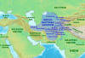
139 AD | Ptolemy (83?-161? AD) writes that in European Sarmatia ‘below Agathyrsi (Akatsirs, Türkic agach ers ‘forest people’) live Savari (Türkic Suvars), between Basternae and Rhoxolani (Tr. Uraksy Alans, i.e. ‘Alans-farmers’) live Huns | 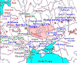
420 | WHITE HUN EMPIRE 420 - 552 A.D  Founder - Aksuvar (Aksungur)  Area - Half of northern India, Afghanistan, parts of Turkistan  (Total Area - 3,500,000 Km2) | 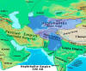
450 | Per Priscus, Sabirs conquered lands of Onogurs, Saragurs and Ugors in steppes around north-western Caspian coast.
453 | After Atilla's death, by drawing lots, to Ellak, eldest of Atilla’s sons, was given ulus (Oguz) of a horde called Sabirs. To Tengiz (DengizikDiggizikh), was given ulus (Oguz) of a horde called Kutrigurs (Kuturgurs/Kotrags = West Wing, from köturi = behind = “to the west“). To Bel-Kermek (Hernach/Irnik/Ernik), youngest, was given ulus (Oguz) of a horde called Utigurs (Utragurs/Utigurs = East Wing, from utra = front, opposite = “opposite side“ = “to the east“. This distribution indicates that Sabirs were a Center Wing, called “otra“, extending from N.Caucasus to Don and Seim rivers.
454 | Coalition of Germanic clans defeats and kills Ellak in battle. Sabirs without Ellak retreat to the East, through Pontic Steppes, to Daghestan. Kutriguri and Utiguri under Bel-Kermek (Hernach), fell back to 'Ugol' (Ul = frontier) place that corresponds to Bessarabia.
469 | Western Hunnish clans retreated. Utigurs to Azov-Taman SE of Sea of Azov. Kutrigurs to between Dniepr and Don Rivers, NW from Sea of Azov Utigurs. Sabirs in Daghestan SE of other two Hunnic hordes, between Daryal Gorge and Kuma River on the Caspian Sea.
505 | Sabirs from Pannonia begin to immigrate to North Caucasus and Itil valley
505 | Sabirs created a powerful federation of akin tribes, “Kingdom of Huns“. They were populous and had an army of 20,000 well equipped cavalrymen. They were masters of art of war and build siege machines unknown even to Persians and Byzantines. 20,000 army indicates 90-100,000 strong tribe
552 | End of WHITE HUN (EPHTALITE) EMPIRE 420 - 552 A.D  Founder - Aksuvar (Aksungur)  Area - Half of northern India, Afghanistan, parts of Turkistan  (Total Area - 3,500,000 Km2)
552 | Sabirs switch from allying with Iran to Byzantine and conquer Agvania. Byzantine conquer Italy
554 | Persians defeat Sabirs in Agvania.
555 | Date of Zacharias Rhetor list of thirteen Hun or Turkic peoples who live in tents, No 3 is sbr Σάβιροι Sabirs Huns, or Huns-Savirs
558 | Avars first crushed Türkic Sabirs, allies of Byzantine, who lived on Kuma river and in Dagestan. Avars then crushed Uturgurs, a Bolgarian tribe and also allies of Byzantine, living between Itil and Don, then crushed Zals and Ants on both sides of Don.
558 | Sabirs (Suvars) are scattered, Dagestani Savirs are not affected, but Don/Donets Savirs pull back northward, to Chernigiv-Sever area. Sever is Sl. for Suvar
558 | Invading Avars attack Hunno-Bulgars. Utiguri, Kutriguri, and Sabiri conquered (559-560).
558 | Avars defeat Sabirs in N Caucasus
558 | Avarian embassy to Byzantium. Avars defeat Sabirs and Ants.
560 | Avar Kaganate extended from Itil to mouth of Danube. Bolgars are split, with Kuturgur Huns (also listed are Onogundurs (10 Oghur Confederation), Hunnogurs, Sabirs belonging to Avar Kaganate, and Utugur Huns (30 Oghur) and Khazars loyal to W. Kaganate
561 | Sosroi Nushirvan crushes Sibirs
565 | Avars subjugate Hunnugur and Sabir, and other Hunnic hordes, assimilating them under Avar Kaganate.
565 | After defeat of their forces by Avars, Khazars took lead in Sabir-Khazar federation. Part of Sabirs move north, to Middle Itil region, among settled there Bolgarian tribes. Their main city Suvar is a great center of Itil Bolgaria.
575 | Byzantines entered Caucasian Albania in 575 to subdue residing there Savirs and Albans. Savirs revolted against Byzantine domination and Byzantine generals came forced Savirs and Alvans to move to this side of river Cyrus (Kura) and henceforth remain in Roman country” | 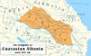
576 | Embassy of Caucasian Savirs and Alans to Byzantine. Emperor Tiberius (578-582) promised Savirs and Alans more favorable terms of alliance than Persian terms
610 | Future Gokturk’s Sibir-Khan (14), Mokhodu, of the most western ulus, is baptized in Constantinople. This starts his fight with Buri-shad (34) (610-618) and Tardu Yabgu (Tun(g)-Yabgu) (23) (618-630). Kubrat is not baptized.
630 | Gokturk Kaganate’s Sibir-Khan (14) recognized independence of Bolgaria under Kubrat of Dulo dynasty, his nephew of feminine line. Notably, the tribal symbols of the Dulo clan of the Bulgars and the Qayn (Kayı) tribe of the Oguzes are the same | 
630 | Qarluqs rebel against Gokturk Kaganate, Tung Yabgu (23) dies, W. Kaganate split, SW and NE. SW run by Nushibis, under Irbis Bolun Yabgu (31) (631-631), installed by Nishu Khan Shad (32), son of Baga Shad (24). NE run by Tele (Dulu), under Sibir Khan Yabgu (14) (630-631).
631 | Irbis Bolun Yabgu (31) replaced by Nishu Khan Shad (32) as Dulu Khan (631-634). Sibir Khan Yabgu (14) killed. W. Gokturk Kaganate reunited.
635 | Kubrat escaped dominance of Gokturks and Khazars, by supporting Sibir-Khan in 630. He became independent, defeated Avars. Controlled area near Pontic steppes
700 | Sabirs are identified with Romny-Borshchev (8th-10th cc., Lipetsk, Voronej, Bryansk, Kursk and Belgorod provinces) and Volyntsevo (8th-9th cc., between Dnieper and Don rivers) cultures
820 | Sabirs are listed in Sogdian document found in Turfan, conditionally named Naf Namak, Remnants of Sabirs remained in Turfan neighborhood long after 5th c. migrations, scholars placed their home-country near Turfan, making Sabirs the known Türkic tribe that lived in symbiosis with Kucha and Argi people (mislabeled “Tokharians”) | 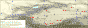
864 | Between 864 and 884. First assault of Norman/Viking/Varyag/Ruses on Tabaristan Province of Arab Caliphate with at least some Türkic population of Gilans, Kayi Huns, Masguts, and Savirs. Ruses attacked largest southern port city Abaskun in Astrabad Bay, reportedly Amir killed all Ruses.
882 | Salahbi Yolyg (aka Oleg, Oleg the Seer, Olaf, 882-912), Kyiv Ilchibek (regent) for Igor (Ugyr Lachini, 912-945, aka Igor I the Old, Ingvar) set out down river to capture Slavic Dnieper Krivicheys with their ruler's seat in Shamlyn (future Smolensk), and then sailed down to Suvars (Slav. Severyans) and took Lübech, the seat of ruling Khan Alabuga of Baryn line of Suvars. Possibly one of captured Khan Alabuga's daughters became household slave in Salahbi Yolyg household, Malusha intendant (keyholder) of Lübech, who later bore Kiev Knyaz Vladimir. Mal is “cattle” in Türkic, with derivatives “wealth, money, treasure”, Malusha is diminutive form with connotation “precious”, adopted by Slavs. Mal was a popular name in pre-Hunnic n.Pontic.
882 | Khan Alabuga of a Baryn line of Sabans (Slavic “Berendeis) starts a city later named Bilyar.
884 | Salahbi Yolyg (aka Oleg, Oleg the Seer, Olaf, 882-912), Kyiv Ilchibek (regent) for Igor (Ugyr Lachini, 912-945, aka Igor I the Old, Ingvar) raids Khazarian subjects Suvars (Slav. Severyans), defeats them and imposes a nominal tribute, adding Suvars to his “Rus“ realm. Suvars split, one part remaining in place, and part migrating NE to Itil-Kama interfluvial, area of future city Nur-Suvar
895 | Itil Bolgaria census lists 550K, 200K are Saban-speaking Bulgars (Suvars), 180K-Ars (Udmurts, Finno-Ugors), 170K-Modjars (Mordva)
907 | Byzantine treaty of 907 with (Kyiv? Itil?) allocates a separate tribute to capital of Suvars Chenigov (Karajar)
909 | Between 909 and 913. Second assault of Norman/Viking/Varyag/Ruses on Tabaristan Province of Arab Caliphate with at least some Türkic population of Gilans, Kayi Huns, Masguts, and Savirs. Ruses attacked again largest southern port city Abaskun in Astrabad Bay, then Sari in Hyrcania (Yiyrks). Gilan force reportedly killed all Ruses.
913 | Largest campaign of Norman/Viking/Varyag/Ruses in Caspian, devastation of Gilan, Deilem, Tabaristan, Abaskun, attacked Baku in Azerbaijan and Shirvan with significant Türkic population of Gilans, Kayi Huns, Masguts, Yiyrks, Azeri, and Savirs. Khazars demolish Rus marauding expedition fleet | 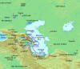
922 | City Nur-Suvar founded (922-1246). Present name Tatarskiy (Sham-Suar).
930 | Itil Bulgaria has 30 cities. Khasan built: Matak, Nukrat, Bandja (Samara ) (Center of Mardan-Bellak ulus), Bulyar (citadel in Bilyar), Kamysh, Simbir, Gazan-Deber, Kashan, Tukhcha, Tau-Kerman (Sviyajsk), Tash-Bolgar, Subash-Simbir, Karadjar, Djilan
943 | Campaign of Norman/Viking/Varyag/Ruses in Caspian, capture of Agvan capital Berdaa at a tributary of Kura in Azerbaijan, devastating city, but with large losses. Agvan had significant Türkic population of Gilans, Kayi Huns, Masguts, Azeri, and Savirs.
964 | Bulgarian annals provide background information on the Rus campaign against Khazaria, depicting it as a Bulgar liberation war of joint Bulgar-Rus alliance, where Bulgaria paid Ruses for the campaign by leasing out provinces Djir (future Rostov province and city of Russia), Kan (future Murom province and city) and the western Kortdjak (future Moscow, Vladimir and Ivanovo provinces), for an annual tribute equal in size to the tribute from Djir (Bulgar-Rus Treaty of 964). In the campaign participated Turkmens (Oguzes), recently defeated in the lengthy Bulgar-Turkmenian war (ca. 947-ca. 960), and Bajanaks, whose territory the Rus army had to cross, as Rus allies in the campaign. The annals describe Rus army as consisting of 20 thousand Vikings and 50 thousand Slavs.
966 | Bandja (Fanagoria), capital of Great Bulgaria in VII c, destroyed by Kiev Knyaz Svyatoslav. Escaped inhabitants established New Bandja in Jiguli on Itil (Murom setlement). During campaign were devastated cities in the North-East Caucasus, including Semender.
977 | Ibn Haukal ( Ibn Hawkal) in the “Face of the Earth“ records that Azeri and Persian languages were being used as Lingua Franca across the Caucasus. Ibn Haukal mentiones Azeri language as lingua franca across the Caucasus 2 centuries before Azeris reach Caucasus in “consensus“ version of history
1239 | Batu and Yaroslav (Yaroslav Vsevolodovich, 1191—1246, brother and hair apparent of Vladimir's Grand Prince Yury Vsevolodovich) attack together Chernigiv principality (Chernigiv-Sever)
1246 | City Nur-Suvar destroyed (922-1246). Present name Tatarskiy (Sham-Suar).

Home  Back  In Russian  Contents Huns  Contents Bulgars | Sources  Roots  Writing  Language  Religion | Genetics  Geography  Archeology  Coins  Wikipedia | Z.Miftakhov On Sabirs  Kamoliddin Toponymy | Besenyos, Ogur and Oguz  Kurgan Culture  Andronov Culture  Afanasiev Culture  Karasuk Culture  Russian Version needs a translation | Alan Dateline  Avar Dateline  Besenyo Dateline  Bulgar Dateline  Huns Dateline  Karluk Dateline | Kimak Dateline  Kipchak Dateline  Khazar Dateline  Kyrgyz Dateline  Sabir Dateline  Seyanto Dateline
Updated on: 9/14/2005

